**Investigations of Wave-particle Duality in the Behavior of Light and Atoms**

22 October 2023

CHEM 1310L Laboratory

*Introduction*

**Part A**

In part A of this experiment, we replicated Young’s double slit experiment by using a diffraction grating that had more than just one slit. These slits are separated by a distance on the order of micrometers. In the end, this experiment illustrates the wave nature of light due to the constructive interference for the dots on the wall. Due to the wave nature of light, as the distance between the diffraction grating and the wall increases, the distance between each dot on the wall increases. Additionally, the wavelength of the light plays an integral role in this dependence; as the wavelength of the light increases, the distance between each diffraction grating also increases.

**Part B**

For a specific atom, the energy levels of an electron are quantized in discrete energy levels. In other words, electrons exist only at specific areas of the atom that give it discrete energy levels; they cannot be floating between such levels. As a result, when a photon is incident on an atom, it must be of at least a specific energy for the electron to jump between energy levels. For the photoelectric effect, the wavelength of light has an inverse relationship on the kinetic energy of ejected electrons. In other words, the smaller the wavelength, the more energy each electron has once it is ejected.

**Part C**

As explained in part B, the quantum model of the atom describes how the energy levels of any atom, including hydrogen, is defined in discrete energy levels. When an electron jumps between two energy levels, there is an associated change in energy (∆E). This ∆E is the difference between the energy levels of which the electron jumped between. Using this value in conjunction with the following equation:

$$∆E= \frac{ℏc}{λ}$$

We can deduce the wavelength of light emitted/absorbed for the jump an electron makes in a hydrogen atom. As hydrogen is ionized, there will be an emission of photons at certain wavelengths which represents the energy levels that electrons jump in between.

**Part D**

Likewise, for the emission spectra for helium and neon are given in discrete values compared to that of an incandescent bulb which produces spectra as a continuous band.

*Data and Results*

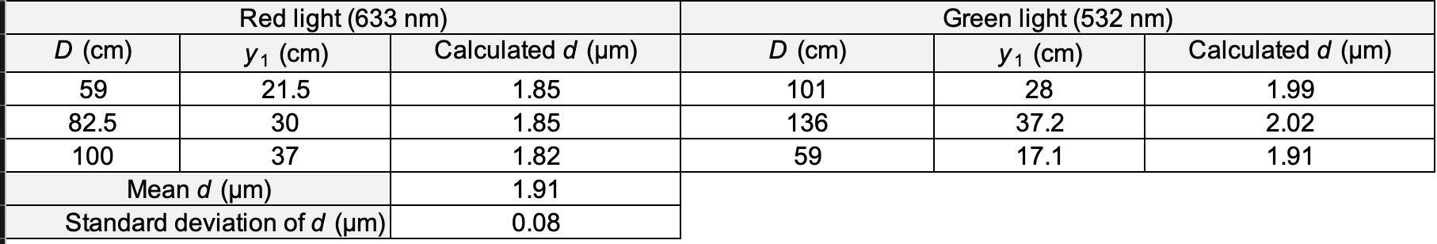

**Table 1.** Distance measurements for diffraction of red and green laser light.

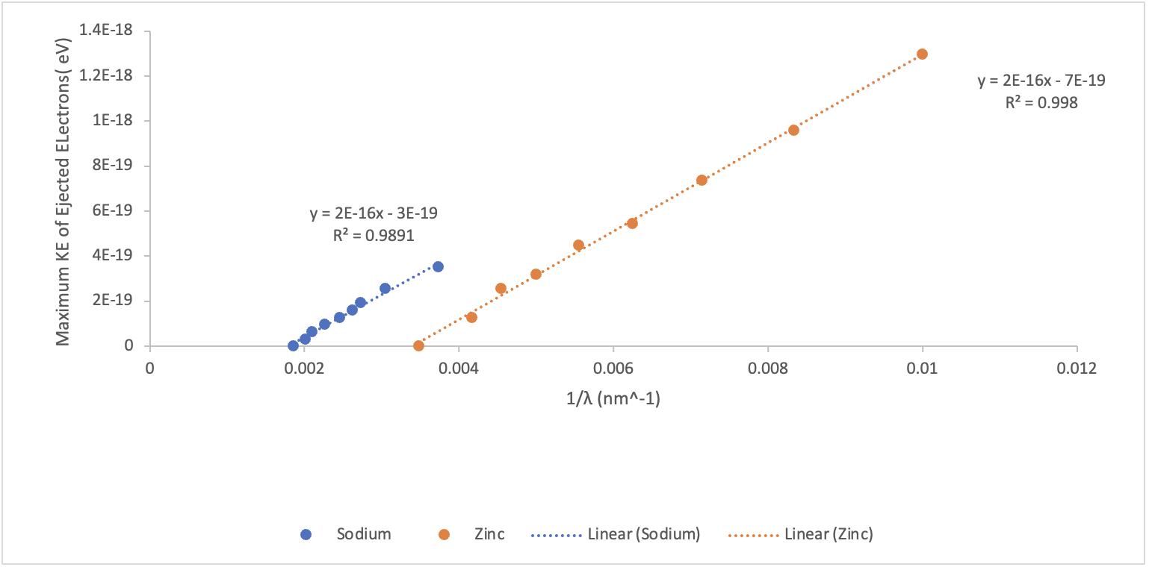

**Figure 1.** Kinetic energy of ejected electrons as a function of inverse wavelength in the photoelectric effect of metals.

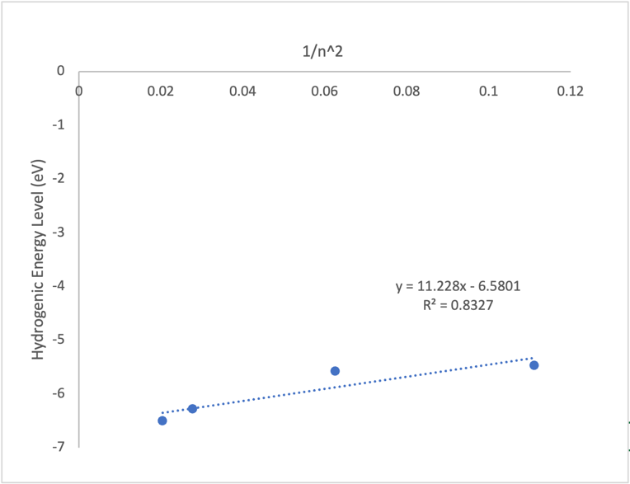

**Figure 2.** Energy levels of the hydrogen atom as a function of 1/*n*2.

**Figure 3.** Visible emission spectrum of Neon.

**Figure 4.** Visible emission spectrum of Helium.

*Discussion*

During part A of this experiment, we measured the properties of the wave nature of light. We observed the relationship between the wavelength of light and the distance between each spot on the wall once the light has passed through the diffraction grating. Using the following equation:

$$\frac{λ}{d}= \frac{y_{1}}{\sqrt{y_{1}^{2}+D^{2}}}$$

And rearranging for d (the separation of the diffraction grating films)

$$\frac{λ\sqrt{y_{1}^{2}+D^{2}}}{y_{1}}= d$$

During the experiment, we measured values for D, the distance from the diffraction grating to the wall and the distance between each spot on the wall ($y_{1}$). For each iteration, we calculated values for d and found an average over three trials to be 1.91 micrometers. We performed this experiment for both red and green light to introduce variance for the wavelengths. As a result, this average factors in how light at different wavelength diffracts through the grating.

The average separation of each slit, 1.91 micrometers is precise only up to $±.08$ micrometers – the standard deviation of the data set – indicating a 4.18% error from the mean.

Referring to figure 1, the energy of the ejected electrons is graphed with respect to the inverse of wavelength, or the frequency of the light. As the frequency increases, or the wavelength decreases, the energy of the ejected electrons increases as well. This follows the dependence wavelength has with respect to the energy outlined in the following equation:

$$E= \frac{ℏc}{λ}$$

Where there is an inverse relationship between wavelength and energy.

For determining the energy level of the ground state in hydrogen, n = 1, we can confer with the following equation:

$$∆E= -R(\frac{1}{n_{f}^{2}}-\frac{1}{n_{i}^{2}})$$

When we distribute the coefficient in, we get:

$$∆E= \frac{-R}{n_{f}^{2}}+\frac{R}{n_{i}^{2}}$$

In the context of our experiment, the final energy level is 2 and the initial energy level is our variable – specifically, the inverse squared of the energy levels is our independent variable. The line of best fit in figure 2 tells us that the slope is our constant ($R=11.28$). The following manipulations will lead us to the energy level associated between n = 2 and n = 1.

$$y=11.28x-6.5801$$

$$∆E= 11.28\left(\frac{1}{n_{i}^{2}}\right)-\frac{R}{n_{f}^{2}}$$

$$∆E= 11.28\left(\frac{1}{1}\right)-6.5801$$

$$∆E_{2→1}= 4.69$$

The energy associated with ground state (n = 1) is $-8.09$ eV. As a result the model for the energy levels of hydrogen has n = 1 far below n = 2 where the energy level for 2 is $-3.40$ eV, as show in the image below.

